Influence of sex steroid hormones on the neuroendocrine effects of evening light exposure in healthy adults

Carolina Guidolin 1, 2, [[0009-0007-4959-2667](https://orcid.org/0009-0007-4959-2667)], Maydel Fernandez-Alonso 2 [0000-0002-3179-7476], Johannes Zauner 1 [0000-0003-2171-4566], Josef Trinkl 2, 3 [0009-0008-9064-4972], Stephan Munkwitz2 [0000-0002-9559-5566], Manuel Spitschan1, 2, 4, 5 [[0000-0002-8572-9268](https://orcid.org/0000-0002-8572-9268)] *

1 TUM School of Medicine and Health, Department Health and Sports Sciences, Chronobiology & Health, Technical University of Munich, Munich, Germany

2 Max Planck Institute for Biological Cybernetics, Max Planck Research Group Translational Sensory & Circadian Neuroscience, Tübingen, Germany

3 University Hospital and Faculty of Medicine, University of Tübingen, Tübingen, Germany

4 TUM Institute for Advanced Study (TUM-IAS), Technical University of Munich, Garching, Germany

5 TUMCREATE Ltd., Singapore, Singapore

* Corresponding author: Manuel Spitschan (manuel.spitschan@tum.de).

# Supplementary materials

## Participants compensation strategy

|  |  |  |
| --- | --- | --- |
| **Group** | **Aspect of the study** | **Compensation** |
| NC group | Experimental sessions (n=5) | €100/session |
| Bonus for flexible scheduling of experimental sessions | €10/session |
| LH testing | €1/LH test performed and logged |
| MCOC group | Experimental sessions (n=5) | €100/session |
| Logging pill intake timing | €1/day of logging pill intake |
| HM group | Experimental sessions (n=5) | €100/session |
| All groups | Weeks of regular sleep/wake schedule duration and logging (sleep diary) | €10/week |
| Logging of mood symptoms | €1/log |
| Bonus for completing all experimental sessions and the discharge questionnaire | €100 |

Table S1: Compensation strategy for participation in the study.

## Calculation of effect sizes from existing literature on sex-and hormone-related differences in non-visual effects of light

In order to make informed decisions about our study design and sample size, we performed a detailed overview of effect sizes in existing literature on sex- and hormone-related differences in non-visual effects of light. We calculated effect size for n=12 studies that we identified and described using an Open Research Knowledge Graph (ORKG) comparison (Guidolin & Spitschan, 2024). Calculation of effect sizes and details on the approach taken are summarised in a reproducible R markdown available at <https://github.com/tscnlab/GuidolinEtAl_PCIRRStage1_2025/tree/main/effect_sizes>. A summary of these effect sizes in shown in Figure S1 and S2.

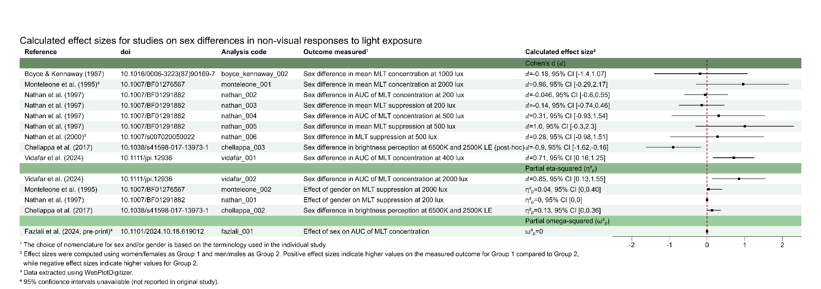  
 Figure S1: Calculated effect sizes for studies on sex differences in non-visual responses to light exposure.

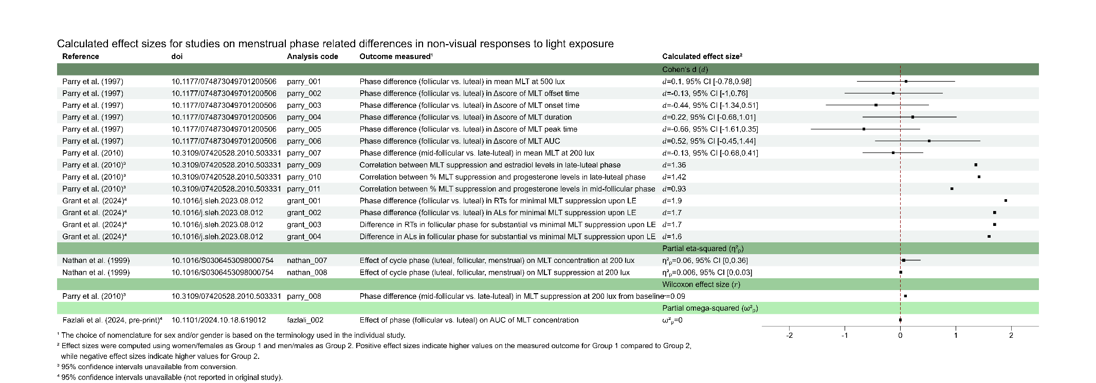  
 Figure S2: Calculated effect sizes for studies on menstrual phase related differences in non-visual responses to light exposure.

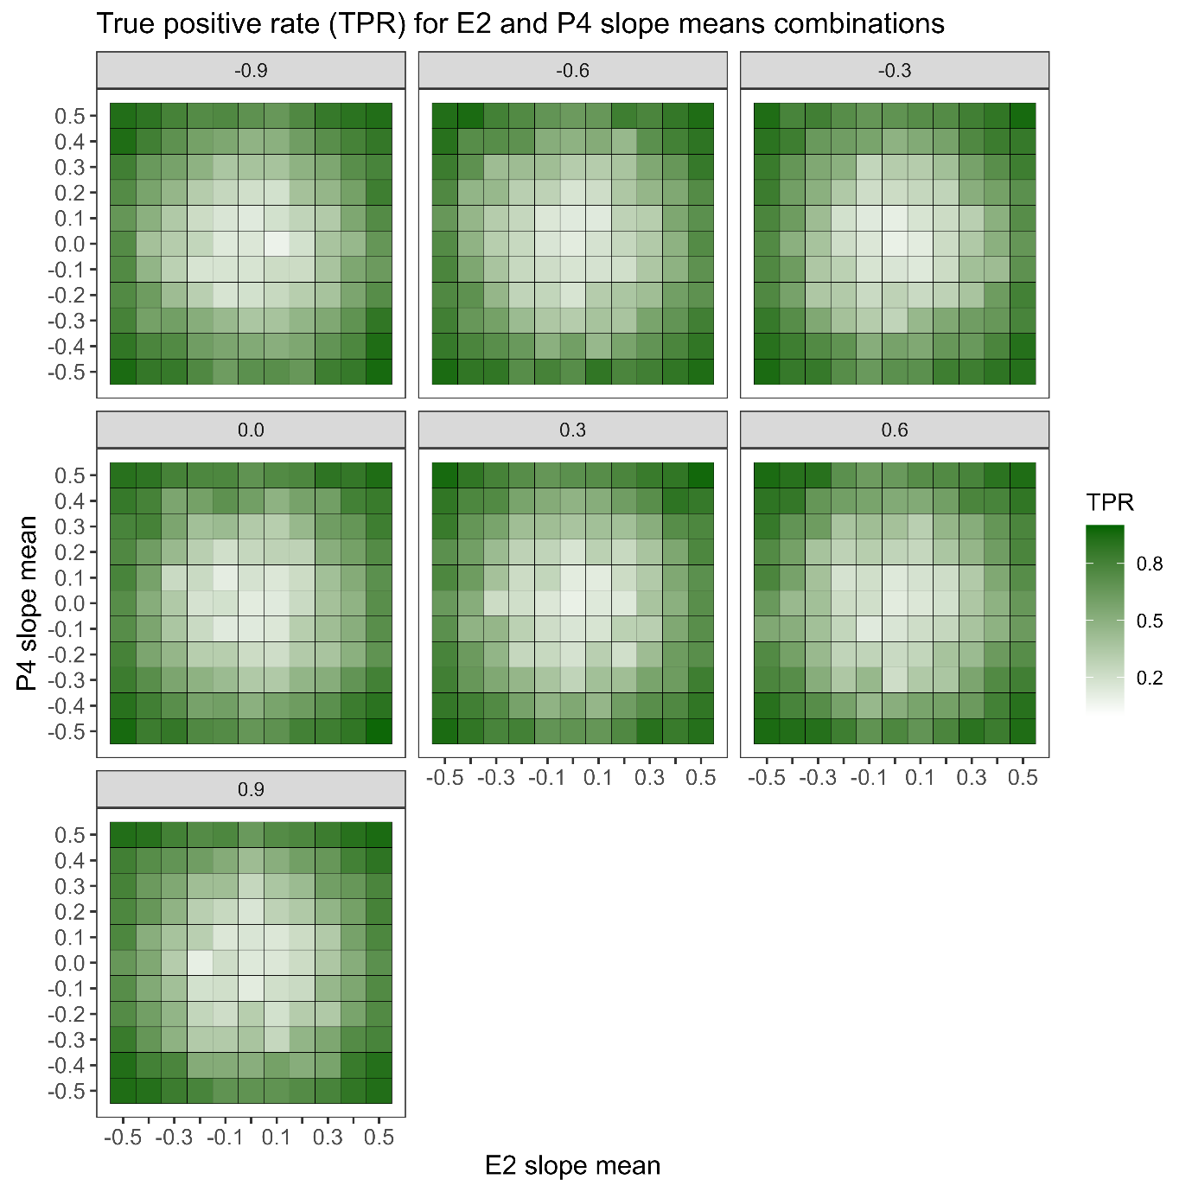

Figure S3: Heatmap of E2 slope mean and P4 mean combinations across intercept mean values. Darker green indicates a higher probability of detecting an effect under the fixed-n BFDA simulation. Each facet represents a different intercept mean value. Each cell in a given facet represents the TPR for the 100 simulations performed drawing from a normal distribution with possible means -0.5 to 0.5 at 0.1 steps and standard deviation 0.2 (for both E2 and P4 slopes), with a given intercept mean value (indicated by the facet label). Intercept values for data simulations are also drawn from a normal distribution with possible means ranging from -0.9 to 0.9 at 0.3 steps and standard deviation 0.2.

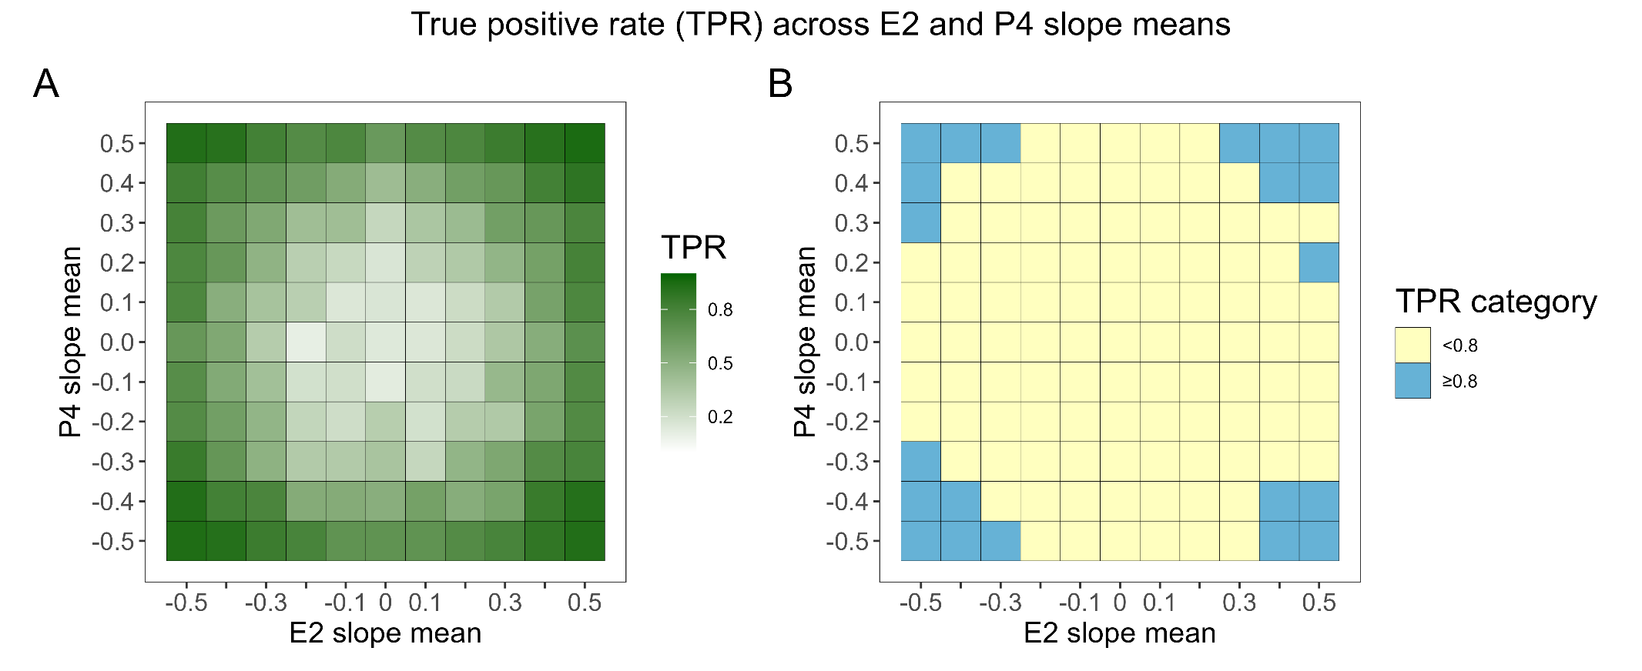

Figure S4: Heatmap of the TPR for each combination of E2 and P4 slope means, aggregated across different intercept mean values. (A) Darker green colours represent high TPR values. (B) Blue cells show E2 slope mean and P4 slope mean combinations yielding high TPR values (≥0.8). Yellow cells show E2 slope mean and P4 slope mean combinations yielding low TPR values (<0.8).

### Stopping principles

Throughout data collection, various stopping principles will be applied to each participant group.

|  |  |  |  |  |  |
| --- | --- | --- | --- | --- | --- |
| **Group** | **Aspect** | **Principle** | **Assessment method** | **Adjustment for following experimental sessions** | **Consequence on already collected data** |
| **NC group** | Cycle length | Menses onset on cycle 1 occurs ≥9 days prior to predicted menses onset | Self-report of menses onset on mobile app | Participant cannot take place in the study. Participation is possible for future cycles | The dim light condition experimental session data will not be used for analysis. If the participant takes part in the experiment in future cycles, this experimental session has to be repeated. |
| Ovulation | Cycle 1 is anovulatory | Self-report on mobile app and picture evidence for no positive result for LH test during cycle 1, even if E2 positive test is obtained | Participant cannot take place in any experimental session during the current cycle, but participation is possible for future cycles | The already collected data for the dim light condition and the peri-ovulatory phase will not be included in the analysis. If the participant takes part in the experiment in future cycles, both experimental sessions have to be repeated. |
| Cycle length | Luteal phase of cycle 1 ≤9 days (day after positive LH test to day before subsequent menses onset) | Self-report of menses onset on mobile app | Participant cannot continue participation in the study, but participation is possible for future cycles | The already collected data for the dim light condition can be kept and, if the participant decides to take part in future cycles, it does not have to be repeated. Peri-ovulatory and mid-luteal sessions would have to be rescheduled |
| Ovulation | Cycle 2 is anovulatory | Self-report on mobile app and picture evidence for no positive result for LH-test during cycle 2, even if estradiol peak detected in the days before | N/A, no future experimental sessions are planned | No influence on peri-ovulatory, mid-luteal, and perimenstrual session. Data from the mid-follicular phase has to be re-collected. If this is not possible, it will not be included in the analysis |
| Cycle length | Luteal phase of cycle 2 ≤9 days (day after positive LH test to day before subsequent menses onset) | Self-report of menses onset on mobile app | N/A, no future experimental sessions are planned | No influence on peri-ovulatory, mid-luteal, and perimenstrual session. Data from the mid-follicular phase has to be re-collected. If this is not possible, it will not be included in the analysis |
| **MCOC group** | Pill intake | Took the pill at the wrong time, i.e. not after wake-up | Lack of timely self-report on mobile app, or email communication to researcher | Participant is asked to take the pill as soon as possible. If this is the day of an experimental session, participation is possible if the oral contraceptive is taken at least 10 hours prior to HBT | No consequence, since not influenced |
| **All participants** | Circadian stabilisation | 1x deviation from target bed or wake time > ±30 minutes in the three days prior to an experimental session | Sleep diary and visual check of actigraphy data | Participant cannot participate in future experimental sessions | Data from other experimental sessions is kept and included in the analysis |
| Alcohol intake | Alcohol intake on experimental day | Breathalyzer ACE results>0.05 | Participant cannot participate in the current experimental session | No consequence. Experimental session will have to be re-scheduled |
| Drug use | Drug consumption on experimental day | Drug-Screen Multi 5 positive (any positive test on the multi-panel) | Participant cannot participate in the current experimental session | No consequence. Experimental session will have to be re-scheduled |
| Ability to follow instructions | Participant is not able to adhere to the protocol | In-person interaction with the experimenter (experimenter judgement) | Participant is excluded from the study | No further experimental sessions will be performed |

Table S2. Overview of the stopping criteria for this study, and consequences for already collected data and to-be-collected data.

## Scheduling principles: NC group participants

  
Figure S5: Example for scheduling a participant of the NC group based on their at-home E2 and LH test results and menses onset. Cells with red contour represent the already planned experimental sessions for the MCOC and HM groups, always falling on Mondays and Thursdays. At screening (i.e. based on data for last six cycles), the participant represented here has an average cycle length of 26 days, and the shortest cycle length is also 26 days. Given the in-person screening on Friday, 7 March, the dim light control session for this NC participant will occur on Thursday, 13 March, following at least five days of circadian stabilisation. Once the participant reports menses onset for cycle 1 (Saturday, 22 March), the day when they should start E2 and LH testing can be calculated based on their shortest cycle length (i.e. menses onset based on shortest cycle length = Wednesday, 16 April. Subtracting 14 days from this day leads to Wednesday, 2 April, and the participants should start testing four days prior this date, meaning Saturday, 29 March). The estimated positive LH test day can also be estimated based on average cycle length of the last six months. Here, it would fall on Wednesday, 2 April. Since an experimental session is planned on Thursday, 3 April, the participant is provisionally scheduled for this date. This experimental session is then confirmed because the participant obtains an E2 positive test on Tuesday, 1 April. The participant then continues testing until they obtain a positive LH test result (here, Saturday, 5 April). From this day, the mid-luteal (red coloured cells) and peri-menstrual (light blue coloured cells) experimental sessions can be scheduled +6 to +10 and +12 to +16 days from positive LH test day (positive LH test day = 0). In this case, the mid-luteal phase session would fall on Monday, 14 April and the peri-menstrual phase session could fall on Thursday, 17 April or Monday, 21 April. The participant reports menses onset for cycle 2 on Sunday, 20 April, and the mid-follicular phase (lilac coloured cells) session can then be scheduled in the time window +4 to +8 from menses onset (which corresponds to day +1). Here, it would take place on Thursday, 24 April. Note that the cycle length for cycle 1 is longer than estimated (29 days rather than 26 based on average). However, our scheduling method still captures all phases as planned, and the peri-ovulatory session takes place prior to the positive LH test, ensuring high and rising levels of estradiol are captured.

+8

## Light-level characteristics for light stimuli delivery through the VR headsets

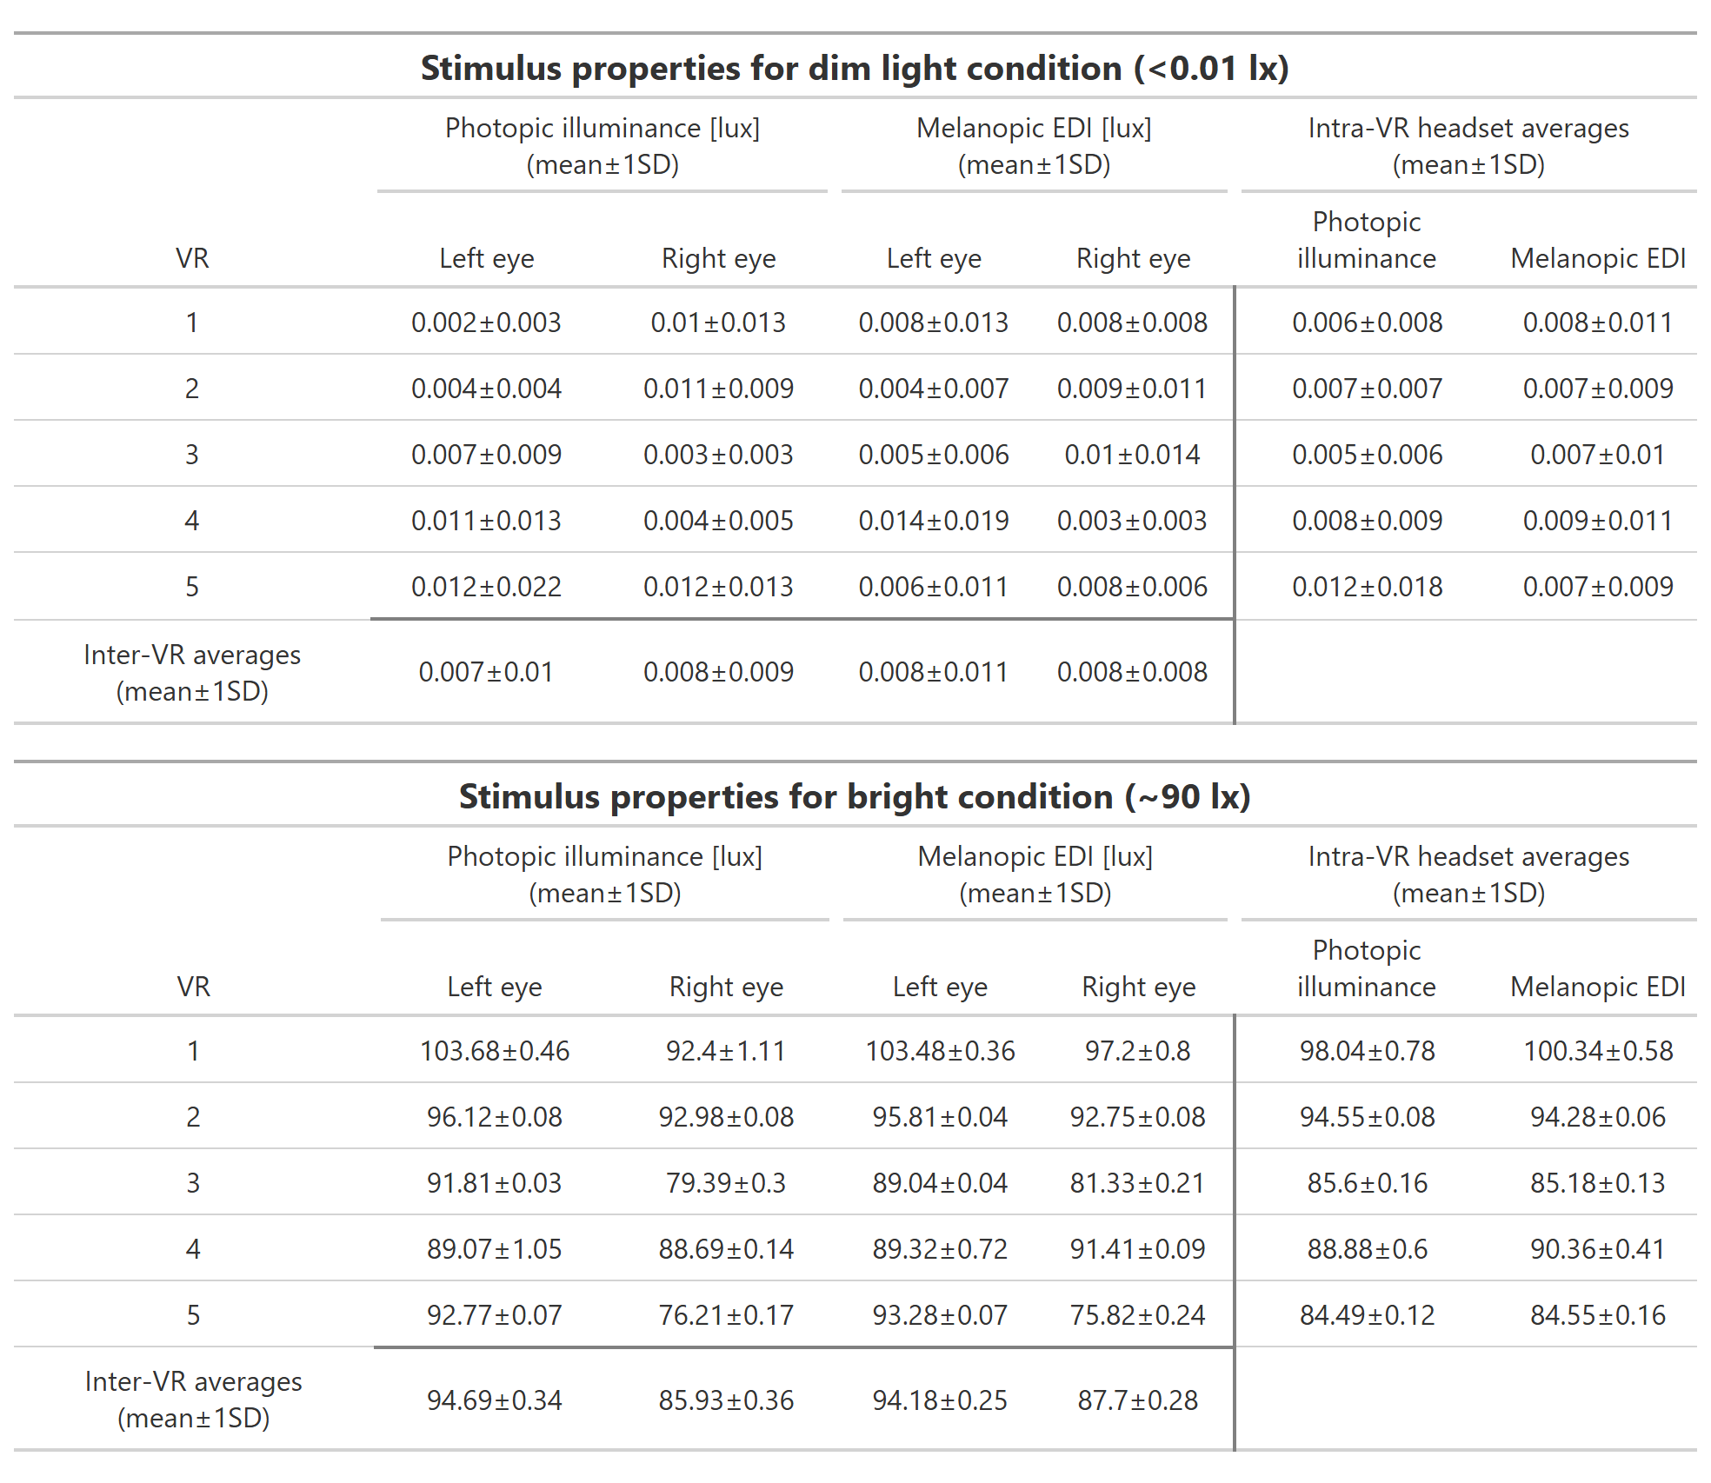  
Table S3: Calibration results for photopic illuminance and melanopic EDI delivery through the five available VR headsets. Each cell of the “Left eye” and “Right eye” columns represents the mean±1SD of five repeats at input intensity 0 (top panel, dim light condition) and at input intensity 0.5 (bottom panel, bright light condition). Intra-VR and inter-VR averages (mean±1SD) are shown.



**Table 1. SAGER guidelines checklist: Studies with human participants**

ds

|  |  |  |  |
| --- | --- | --- | --- |
| **Section / topic** | **Item number** | **Checklist item** | **Reported on page number** |
| **General** | | | |
|  | 1 | The terms sex/gender used appropriately | p.8 |
| **Title** | | | |
|  | 2 | Title specifies the sex/gender of participants if only one included | N/A, both included |
| **Abstract** | | | |
|  | 3a | Abstract specifies the sex/gender of participants if only one  included | N/A, both included |
| 3b | Study population described with sex/gender breakdown* | Will report after data collection |
| **Introduction** | | | |
|  | 4a | If relevant, previous studies that show presence or lack of sex/gender differences or similarities are cited | pp. 5-6 |
|  | 4b | Mention of whether sex/gender might be an important variant  and if differences might be expected | pp. 7-8 |
|  | 4c | The demographics of the study population with regard to sex/gender (eg, disease prevalence among male/female study participants) are outlined* | Will report after data collection |
| **Methods** | | | |
|  | 5a | Method of definition of sex/gender (eg, self-report, genetic  testing) | pp. 9-11 |
|  | 5b | Description of how sex/gender was considered in the design, whether authors ensured adequate representation of male and female study participants, justification of the reasons for any exclusion of male or female participants, or explanation if not considered. Justification of other sex/gender-specific interventions of study designs (eg, mandating contraception for women).* Explicit reporting of the scientific rationale for | p. 7 |

|  |  |  |  |
| --- | --- | --- | --- |
|  |  | contraception requirements and exclusions for pregnancy and lactation should be required* |  |
| **Results** | | | |
|  | 6a | Study population description with complete gender/sex breakdown for all categories considered* | Will report after data collection |
|  | 6b | Where appropriate, data presented disaggregated by sex/gender, and sex/gender differences and similarities are described | Will report after data collection |
|  | 6c | Sex- and gender-based analyses reported regardless of outcome (in main paper if pre-specified; otherwise in appendix)* | Will report after  data collection |
|  | 6d | For clinical trials, adverse event data disaggregated by sex/gender (in main paper if pre-specified; otherwise in appendix)* | Will report after  data collection |
|  | 6e | Patient-reported outcome data disaggregated by sex/gender (in  main paper if pre-specified; otherwise in appendix)* | Will report after data collection |
|  | 6f | For epidemiological studies, the effects of other exposures on health problems examined for all genders and analysed critically  from a gender perspective | Will report after  data collection |
|  | 6g | Table 1 includes separate rows for male sex/gender, female sex/gender and other categories if collected* | Will report after  data collection |
| **Discussion** | | | |
|  | 7a | Potential implications of sex/gender on the study results and analyses, including the extent to which the findings can be generalized to all sexes/genders in a population | Will report after  data collection |
|  | 7b | If a sex/gender analysis not done, a rationale is given and implications of the lack of such analysis on the interpretation of  the results are discussed | Will report after  data collection |
| Adapted from SAGER guidelines. Sex and Gender Equity in Research: rationale for the SAGER guidelines and recommended use. Research Integrity and Peer Review 1, Article number: 2 (2016) [https://researchintegrityjournal.biomedcentral.com/articles/10.1186/s41073-016-0007-6.](https://researchintegrityjournal.biomedcentral.com/articles/10.1186/s41073-016-0007-6)  * These points extend beyond the original SAGER table | | | |

Note: This document is best viewed and completed with Adobe Acrobat Reader.

**ENLIGHT Checklist**



Release 1.0.2, 16 October 2023

The **ENLIGHT Checklist** (this document) and the **ENLIGHT E&E document**

are released under the [CC-BY-NC-ND License](https://creativecommons.org/licenses/by-nc-nd/4.0/). For more information, please visit <http://enlight-statement.org/>.

**General Information**

**Author names: Title of manuscript: Date:**

Carolina Guidolin and Manuel Spitschan

Influence of sex steroid hormones on the neuroendocrine effects of light at night 12 June 2025

|  |  |  |  |
| --- | --- | --- | --- |
| **A. Study Characteristics** |  |  |  |
| **A.1. Protocol-level characteristics** |  |  |  |
|  | **Location (page, figure, table number)** | **Not available** | **Not applicable** |
| Description of experimental setting | pp. 23-25 |  |  |
| Timeline of experiment (including timing and duration of light) | pp. 23-25, Figure 2 |  |  |
| Pre-laboratory sleep-wake/rest-activity behaviour | p. 23-25 |  |  |
| Pre-laboratory light exposure | pp. 31-32 |  |  |
| Immediate prior light exposure (in laboratory) | pp. 23-25 |  |  |
| **A.2. Measurement-level characteristics** | | | |
| Measurement plane (e.g., horizontal or vertical) | pp. 25-26 |  |  |
| Measurement viewpoint and location | pp. 25-26 |  |  |
| Type, make and manufacturer of the measurement instrument | pp. 25-26 |  |  |
| Calibration status of the instrument | pp. 25-26 |  |  |
| **A.3. Participant-level characteristics** | | | |
| Ocular health and functioning | pp. 10-16, Tables 1-4 |  |  |
| Pupil size and/or dilation | pp. 23-25 |  |  |
| Relative time (e.g. to circadian phase or sleep) | pp. 23-25 |  |  |

1. **Light characteristics**
   1. **Light source type(s). Please select all that are relevant.**

Room illumination (overhead or other)

Emissive surfaces including displays (incl. light therapy devices)

Wearable light emitting glasses

Ganzfeld exposure

Other:

**Virtual reality head-mounted display**

✔

Polychromatic light Monochromatic or narrowband light

✔

|  |  |  |  |
| --- | --- | --- | --- |
|  | **Location (page, figure, table number)** | **Not available** | **Not applicable** |
| Type, make and manufacturer of the light source | pp. 23-25 |  |  |
| Use of wearable filtering apparatus (e.g., blue-blocking glasses) |  |  | ✔ |

* 1. **Light level characteristics**

|  |  |  |  |
| --- | --- | --- | --- |
| Illuminance (lux) and/or luminance (cd/m2) | pp. 25-26 |  |  |
| Spectral irradiance and/or radiance distribution | Supplementary materials (digital) |  |  |
| α−opic irradiance and/or radiance (including melanopic) | pp. 25-26 |  |  |
| α−opic equivalent daylight illuminance and/or luminance (EDI/EDL, including melanopic) | pp. 25-26 |  |  |

**NOTE:** Luminance and radiance metrics (as opposed to illuminance and irradiance) are mainly relevant for emissive surfaces.

* 1. **Colour characteristics**

|  |  |  |  |
| --- | --- | --- | --- |
| Peak wavelength and bandwidth |  |  | ✔ |
| Colour appearance quantities (any) |  |  | ✔ |
| Colour rendering metrics (any) |  |  | ✔ |

**NOTE:** Peak wavelength and bandwidth are most relevant for monochromatic or narrowband light sources.

* 1. **Temporal and spatial characteristics**

|  |  |  |  |
| --- | --- | --- | --- |
| Location of stimulus and viewing distance | pp. 25-26 |  |  |
| Temporal pattern (including flash frequency and waveform) | None |  | ✔ |
| Relative or absolute size of the stimulus | pp. 25-26 |  |  |